PUMA PHASE BACKPACK
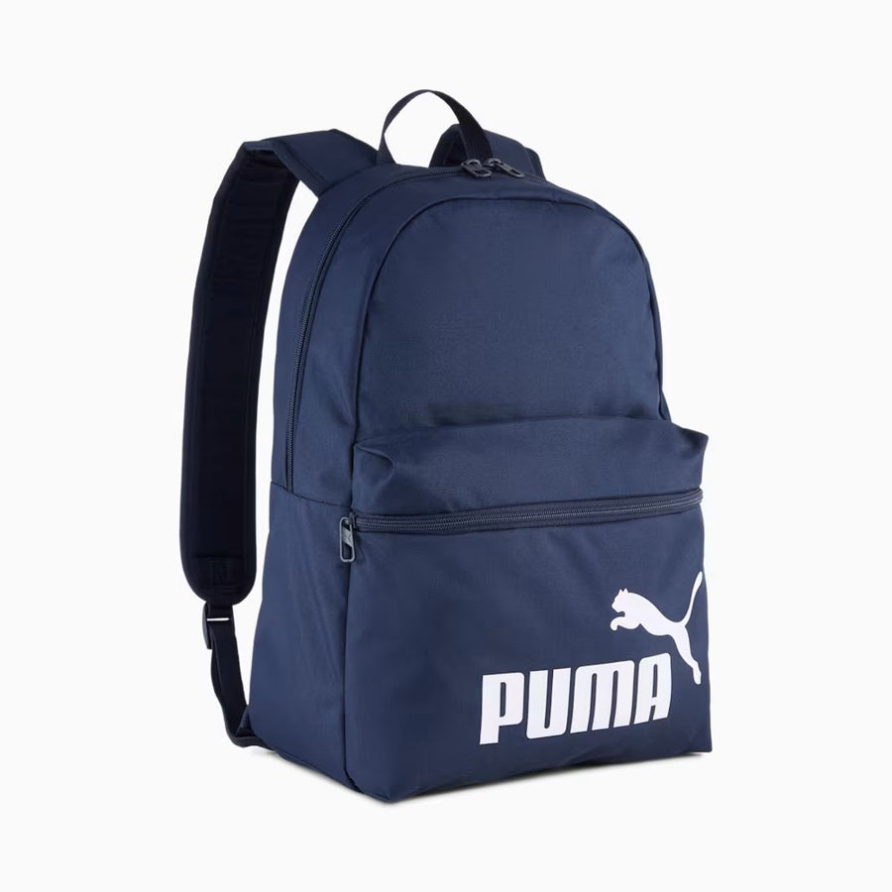
PRICE: Approximately Rs. 6,999

_{Introduction:}
The Puma Phase Backpack is a versatile and stylish everyday backpack designed to meet the needs of students, professionals, and active users alike. With a clean, modern design and spacious storage, this backpack is ideal for carrying daily essentials comfortably and securely. Its lightweight construction makes it easy to wear throughout the day, while the durable materials ensure long-lasting use. Whether you’re heading to school, work, the gym, or casual outings, the Puma Phase Backpack combines practicality, comfort, and iconic Puma style in one reliable carry solution.

Product Overview:
The Puma Phase Backpack offers a spacious main compartment suitable for books, clothing, or daily gear, along with a front zip pocket for quick-access items. Designed for everyday use, it provides comfortable carrying and functional layout.
About the Brand:

Puma is a globally recognized sports and lifestyle brand known for combining performance, innovation, and modern design. Puma footwear is trusted worldwide for its comfort, durability, suitable for both athletic and casual wear.

Key Features:
- Spacious main compartment for daily essentials
- Front zip pocket for easy-access storage
- Adjustable padded shoulder straps for comfort
- Lightweight and easy-to-carry design
- Durable fabric for everyday use
- Classic Puma logo branding

Design & Build Quality:
The Puma Phase Backpack features a clean and minimal design with reinforced stitching for durability. Its structured shape helps maintain form even when fully packed, while the padded back panel enhances comfort during extended use.
Storage & Capacity:
The backpack provides ample space for books, gym clothes, or daily essentials. The front pocket adds extra organization for smaller items such as keys, chargers, making it practical for daily routines.
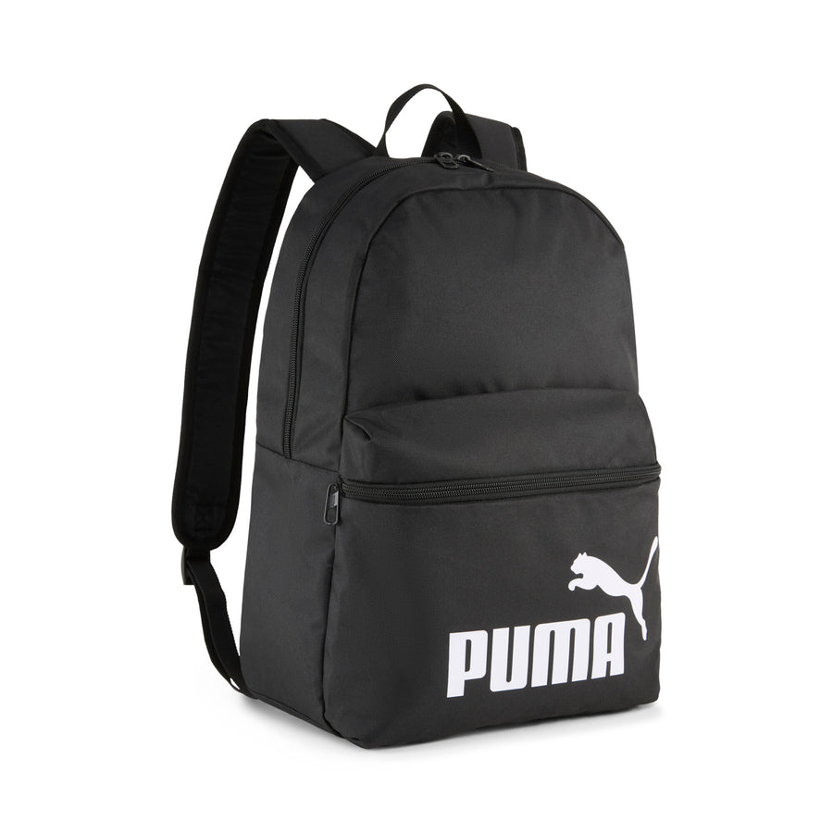

Material & Durability:
Constructed from high-quality polyester, the Puma Phase Backpack is built to withstand regular use. The material is resistant to minor abrasions and maintains its shape over time, ensuring long-lasting performance.
Ideal For:
- School, college, and university use
- Daily commuting and casual outings
- Gym or light travel
- Users seeking a simple and reliable backpack
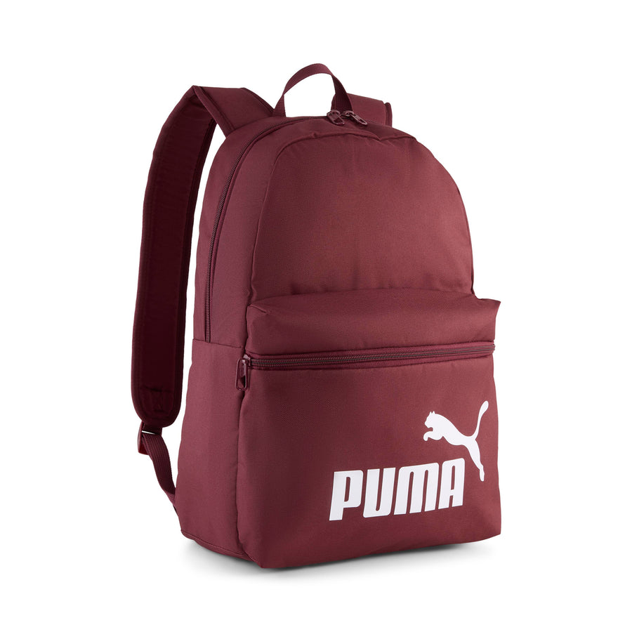

Care Instructions:
- Store in a dry place when not in use
- Wipe clean with a damp cloth
- Do not machine wash or bleach
Product Specifications:
- Brand: Puma
- Model: Phase Backpack
- Product Type: Everyday Backpack
- Material: Polyester
- Compartments: Main compartment + front zip pocket
- Closure: Zipper
- Capacity: Medium
Product Summary:
The Puma Phase Backpack is a practical and stylish everyday bag designed for comfort and durability. With its spacious storage, lightweight build, and classic Puma branding, it’s a reliable choice for school, work, gym, or casual daily use.

